
The Fantasy and Sci-Fi Fanatic’s Podcast Newsletter

News and Updates: December 2023
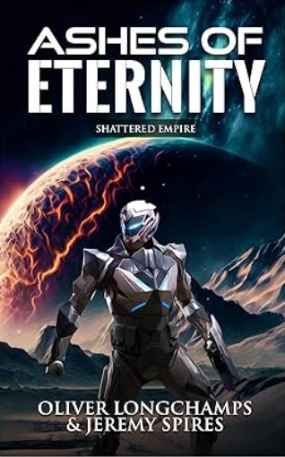
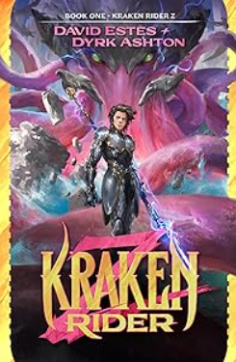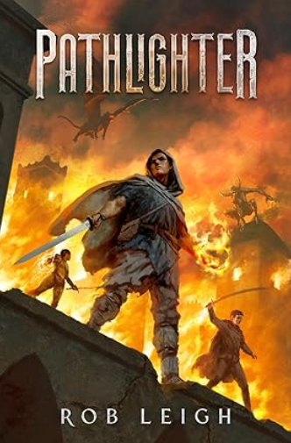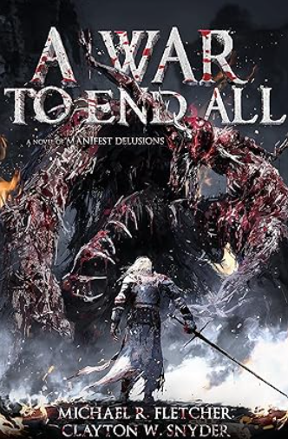
Podcast alumn Dyrk Ashton has his newest release novel Kraken Rider Z with co-author David Estes! Check it out with the link below:
https://www.amazon.com/Kraken-Rider-Z-1-book-series/dp/B0CM5KJD5M

Rob Leigh's epic fantasy debut Pathlighter is ready to be added to your Kindle library. I will be interviewing Rob in the next couple of weeks so be on the lookout for him in the lineup! Here is the link:
https://www.amazon.com/Pathlighter-Rob-Leigh/dp/B0CFQ9W1PM/ref=mp_s_a_1_1?crid=32R1M52R3MT9E&keywords=pathlighter+rob+leigh&qid=1699322171&sprefix=pathlighter%2Caps%2C131&sr=8-1

Podcast alumni Michael R. Fletcher and Clayton Snyder have recently released their novel A War to End All. Check it out with the link below:
https://www.amazon.com/Shattered-Empire-Eternity-Oliver-Longchamps-ebook/dp/B0CLL14DLX/ref=sr_1_1?crid=37BZRYUZ37QYS&keywords=oliver+longchamps&qid=1699634785&sprefix=oliver+longchamps%2Caps%2C238&sr=8-1

Authors Ollie Longchamps and Jeremy Spires new novel Ashes of Eternity: Shattered Empire is ready for your Kindle! Check them out with the link below:
https://www.amazon.com/dp/B0C5S477SF?asc_campaign=07221edb6c129c914a49343fc782a2bb&asc_source=01GRXJEDJ827CJHX3R3R7DB4DN&linkCode=ogi&tag=namespacebran320-20

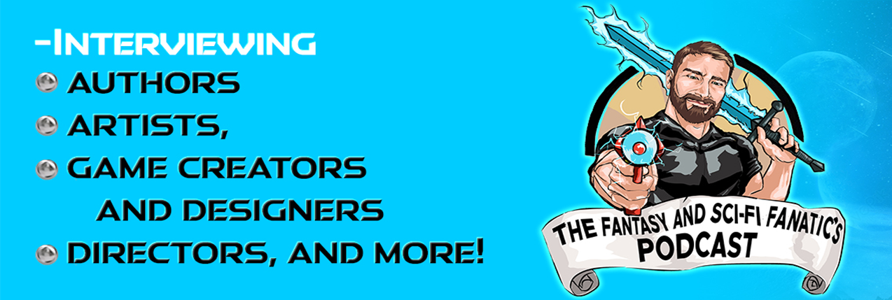
Podcast Release Schedule Season 3:
-Ep. 1: Sienna Frost (9-1)
-Ep. 2: David Boop (9-1)
-Ep. 3: Clayton Snyder (9-10)
-Ep. 4: Sadir Samir (9-17)
-Ep. 5: Michael Michel (9-24)
-Ep. 6: Dylan Brennan (10-1)
-Ep. 7: Steve McHugh (10-8)
-Ep. 8: Steve Guglich (10-15)
-Ep. 9: G.M. White (10-22)
-Ep. 10: H.M. Long (10-29)
-Ep. 11: Anat Eliraz & Allen Chesman (11-5)
-Ep. 12: Anatomy of Fear Anthology Crew (11-12)
-Ep. 13: Michael Gisman (11-19)
-Ep. 14: JCM Berne (11-26)
-Ep. 15: Erin Rado (12-3)
-Ep. 16: Starr Z. Davies (12-10)
-Ep. 17: H.C. Newell (12-17)
-Ep. 18: M.T. Zimny (12-21)
-Ep. 19: Z.S. Diamanti (1-7)
-Ep. 20: Amy Hutchins (1-14)
-Ep. 21: Joe Lee (1-21)
-Ep. 22: Lee Conley (1-28)
-Ep. 23: Erin Moon (2-3)
-Ep. 24: Shami Stovall (2-4)

v
Q: When it comes to guests, who do you interview on your podcast?
We service a wide range of guests on our podcast! We interview authors, writers, artists, craftsman, directors, actors, narrators, toy manufacturers, you name it! If they have something to do with the fantasy, sci-fi, or horror communities and we can learn something from what it is they do!
Q: How long have you been recording episodes for your podcast?
I have been recording episodes for just over two years now. I have recorded over two and a half seasons, and we are currently on Season 3. I have a ton of guests fully signed up for Season 4 and most of Season 5 as well!
Q: How many episodes have you filmed so far?
So far, I have filmed around 130 episodes at the time this newsletter will be released. I still have about 26 episodes to film to finish up Season 3.
Q: What made you get into podcasting?
I really enjoyed the Wizards, Warriors, and Words podcast. I have listened to many others as well and I wanted to help independent authors, artists, and businesses to get their names out there because I am an Indie author myself and I know just how hard it is to get your name out there.
Q: How can I listen or watch your podcast?
We can be found on our YouTube Channel, Rss.com, Spotify, Apple Podcasts, Tune-In, I-Heart Radio, Amazon Music, Podcast Index, Listen Notes, Google Podcasts, and Deezer! You can check out our new website: The Fantasy and Sci-Fi Fanatic's Podcast (thefantasyandscififanaticspod.com) You can also check out our new Linktree with the QR code below!

YouTube Channel Subscription:

https://youtube.com/@thefantasyandsci-fifanatic2328

Rss.com:

https://media.rss.com/thefantasyandsci-fifanaticspodcast/feed.xml

Spotify:

https://open.spotify.com/show/2aCCUhora9GdLAduLaaqiu?si=-SwEaDh-RjGGxQ1XQDitRQ

Facebook join link:

https://www.facebook.com/groups/402724958101648/?ref=share

General Information

