January 2025 Newsletter

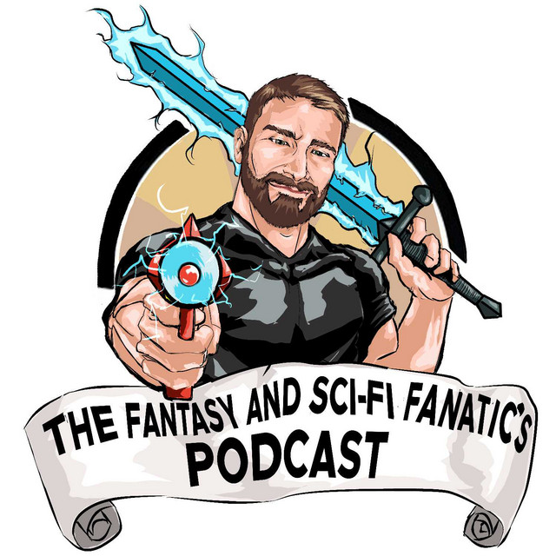
Host: Daniel Coolbaugh
Hello and welcome to The Fantasy and Sci-fi Fanatic’s Podcast Newsletter! I will be sharing news from our podcast community once every month in hopes that you will take a look at what our awesome authors and creators have in store for you. There are so many great books, comics, and other media out there and it is our hope that we get more eyes on all of their hard work! Please make sure to check out our podcast where I interview authors and creators in many different areas of the fantasy, horror, and sci-fi communities. You can find all of our podcast and social media links below:
Podcast Channel Links
Podcast Website
Youtube Channel Subscription
RSS.com Channel Subscription
Spotify Channel Subscription
Facebook Group Join Link
Patreon Link

Abby Goldsmith: Greater Than All: Torth Book Five
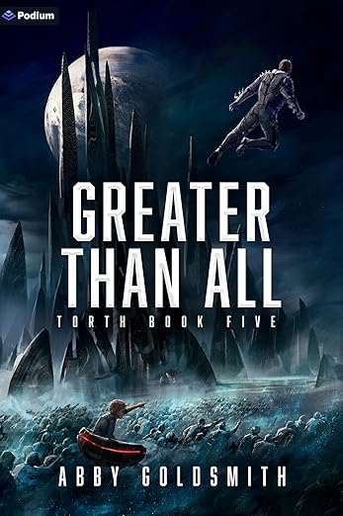
I have interviewed Abby Goldsmith twice and I have added her Majority: Torth Book 1 to my 2025 Reading List. I am excited to start this series as I have enjoyed both of my interviews with Abby discussing her characters, her worldbuilding, and her influences within the genre. Make sure to check out both of our interviews!
Season 3, Episode 37-Abby Goldsmith Interview
Season 4, Episode 1-The Return of Abby Goldsmith
Greater Than All Amazon Link
Book Blurb: The balance of power is shifting in the vicious galactic war against the Torth Majority. The heroes are led by Ariock, a superhuman titan who wins every battle. The secret behind his victories is Thomas, the telepathic renegade supergenius.
But resting on their laurels isn’t an option. Overconfidence could be fatal, thanks to the enemy supergenius known as the Death Architect. And there may be an intrinsic threat among their ranks as well. While Ariock is conquering alien cities and protecting Freedomland, Thomas is transforming the captured Torth into zombified slaves. What better way for Thomas—part human, part Torth—to prove he’s on the side of the good guys than to neutralize their adversary’s minions?
He knows it’ll take more than lumbering prisoners with space dust for brains to win the ultimate war, however, so he’s devising something else. With his superluminal communications technology, all the planets of the galaxy could soon be knitted together in new and frightening ways. One giant hivemind. But are his powers being wielded on behalf of liberty and humanism? Or is Thomas a betrayer helping to galvanize the Torth?
Ally or foe? Ariock is having his doubts. Relying on Thomas could be a grave mistake, but a lapse in trust would be just as bad. Either way, if Ariock makes the wrong decision, freedom will be just a blip in the history of the galaxy . . .
Shami Stovall: Labyrinth Arcanist
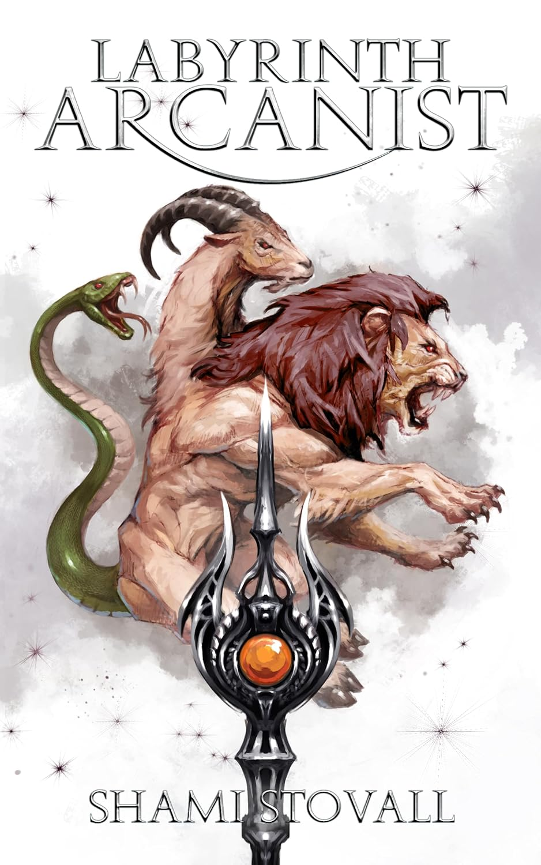
I have interviewed Shami Stovall twice so far and I have always enjoyed our conversations and her books. I just recently finished her newest urban fantasy Time-Marked Warlock. It was fantastic and I always enjoy her writing style and her magic systems. I really enjoyed her book Academy Arcanist so I am really excited to get back to her Astra Academy books. Labyrinth Arcanist looks and sounds amazing so I am excited to read this one as well. Make sure to check out our two interviews to learn more about her books:
Season 3, Episode 26-Shami Stovall Interview
Season 4, Episode 10-The Return of Shami Stovall
Labyrinth Arcanist Amazon Link
Book Blurb: Upgraded weapons. New magic. And a way to enter the abyssal hells…
Gray Lexly has returned to Astra Academy to train himself for the ultimate confrontation. Legendary arcanists from across the world are gathering to assist in the ultimate battle of life and death, but will it be enough to stop the rampaging Death Lords who have amassed power in the abyssal hells?
And before Gray can focus on any of that, he must first get married. With pressure mounting from all sides, Gray is grateful to have Ashlyn at his side, but will it last? The soul fragment from Death Lord Deimos still skews his perception, and sometimes Gray doesn’t feel like himself.
Thankfully, he has his twin brother, Sorin, and his mimic eldrin, Twain, to keep him sane as they prepare to enter the most terrifying part of the abyssal hells: the infamous labyrinth.
Ingrid Moon: The Biohunter Audiobook Kickstarter
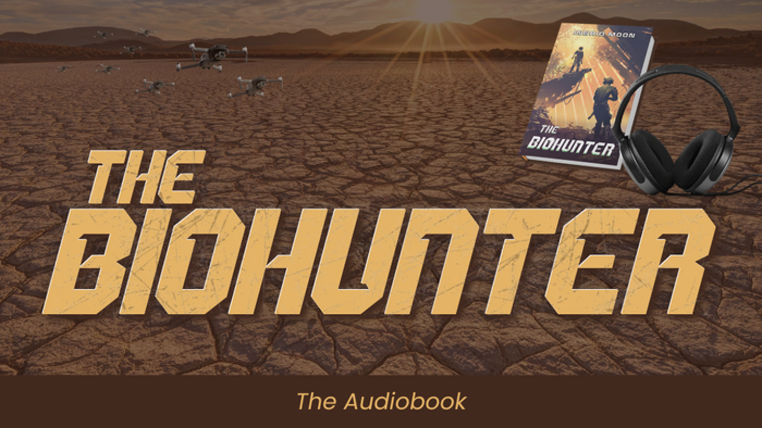
I had the pleasure to interview Ingrid Moon for the first time this past season. We had a great chat about her science fiction books and her writing. I am excited to enter her universe and I am really excited to read and listen to The Biohunter. Make sure to check out her Kickstarter link and her other books. You can find our interview in the link below:
Season 4, Episode 2-Ingrid Moon Interview
The Biohunter Audiobook Kickstarter Link
Book Blurb: Hunt the monsters of the wasteland.
Bring them back alive.
Retire.
Ninety years after the devastating global "Fracture," the biosphere has collapsed. The few remaining cities, once bastions of human survival, have become fortresses of power ruled by ruthless corporations. Axel Mercer, a former soldier, explores the hostile plains to recover organisms for scientific research. But the corporations who run civilization want more.
As his last mission, Mercer is sent to recover a specimen that could bring eternal life to the corporate elites. He learns this organism is not a monster, but a teen girl—a wasteland fighter hardened by a life of survival. Her spirit and fierce determination challenge everything Mercer has believed about his job, his future, and his questionable past.
In a world where power is worth more than life itself, Mercer must decide which side of the fight he belongs on—and what kind of future is worth fighting for.
The Biohunter is an action-packed dystopian novel with a simple premise, crazy twists, cruel desires, a pinch of humor, and all the blood and violence of an edge-of-your-seat action movie.
David Estes and Dyrk Ashton: Thunder Kraken-Kraken Rider Z Book 2
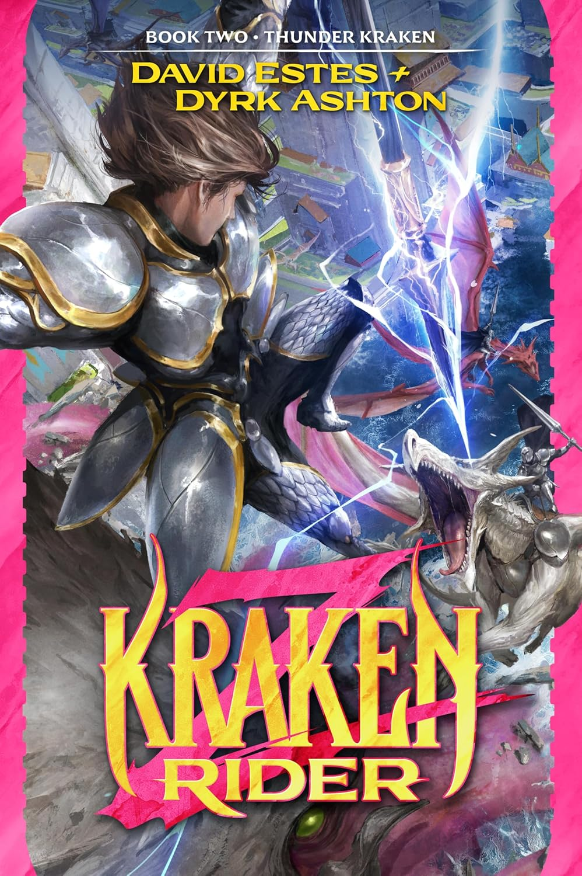
I had the pleasure of interviewing Dyrk Ashton during my first season. He was just starting out with David on their idea for Kraken Rider Z. This one sounds awesome and I am really excited to start book 1 to get caught up and then I am looking forward to checking out book 2. I absolutely love the covers. Make sure to check out me and Dyrk’s interview in the link below:
Season 1, Episode 11-Dyrk Ashton Interview
Thunder Kraken Amazon Link
Book Blurb: Zee Tarrow’s dreams are finally coming true.
While the road to acceptance into Triumf’s Citadel Academy has been filled with pain, suffering, and more joy and surprises than Zee could’ve possibly imagined, now is his time to shine. After all, he’s the first kraken rider in more than a thousand years! Who could possibly defeat him? Except now he must be separated from his best and most loyal friend, the kraken, Jessup, as they both must complete basic training individually in order to pass and become full-fledged cadets.
Easy, right?
Not so much. Rival flights will stop at nothing to defeat or even destroy them, but Zee and Jessup will face far graver danger from mysterious powers who despise them simply for existing. Assassination attempts, monsters of the deep, and the challenges of rising from the sea to live in a world that prefers dry land will thwart them at every turn.
All the while, an evil deadlier than the most powerful dragonrider to ever exist lurks in the shadows, waiting for the perfect moment to come forth and destroy…
If Zee and Jessup are to survive much less thrive, they must forge new friendships, overcome the odds stacked against them, and, above all else, continue to progress their power to levels that haven’t been witnessed in a millennium.
Kacey Ezell and Marisa Wolf: Blood of Her Father
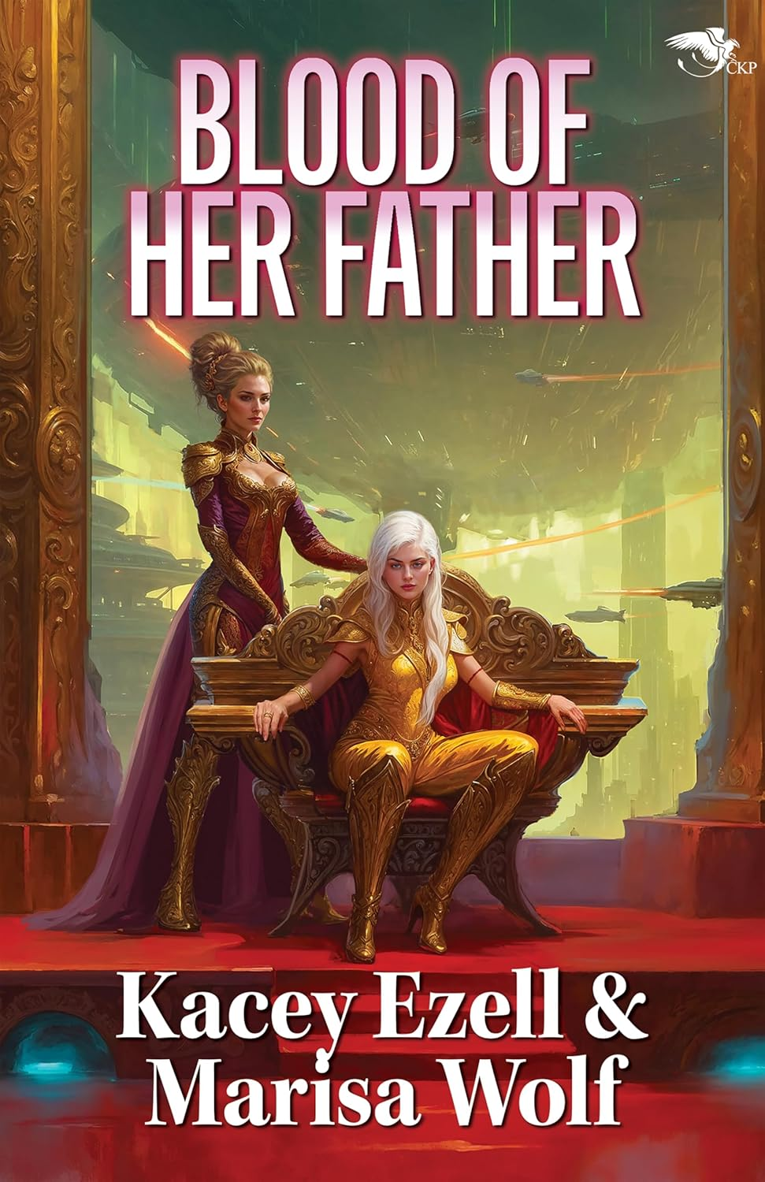
I had the pleasure of interviewing Kacey Ezell and Marisa Wolf for this season and our episode will drop Saturday, March 15th at 12am EST. We discussed their newly released book: Blood of Her Father along with their other co-authored books. This one is on my 2025 Reading List and it is one of my favorite covers I have seen within the genre in some time. Make sure to check out our upcoming interview and their Amazon book link!
Blood of Her Father Amazon Link
Book Blurb: Isonei. Born the bastard daughter of a tyrant king, Isonei took power to save her people from her father’s madness and ambition; however, the young queen of Zhretien must now learn to rule a world where truths are complicated, and motives are anything but clear.
Careline. Married to a king to protect her family, she is now relegated to the position of the queen’s most hated councilor. With her family’s security slipping further and further from her grasp, she must forge a new path to the power and safety she’s spent her whole life seeking.
But when palace politics spill over into Isonei’s royal heartbreak and result in a severe economic crisis for the people of Zhretien, these two women must find common ground and form an alliance to secure Isonei’s right to rule—not only her kingdom, but her thoughts, her choices… and even her very life.

Can two enemies work together, or will they forever be divided by the blood of her father?
Derek and A. L. Borne: Primeval Ranch
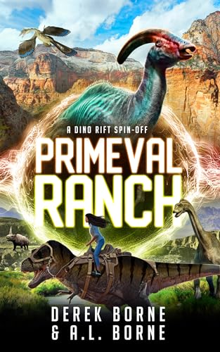
I had the pleasure of interviewing Derek Borne, one of the co-authors of the Dino Rift Series. We had a great chat about dinosaurs, writing what you find fun and exciting, and their plans for the series. Our episode will drop Saturday, April 19th at 12 am EST. Make sure to check out the blurb and the Amazon link below.
Primeval Ranch Amazon Link
Book Blurb: This fast-paced spin-off from Dino-Rift and SauraCorps: Salvation introduces all new characters, including two who use their grief to protect time-displaced dinosaurs, and to honor the ones they love. In true Borne fashion, this sci-fi fantasy adventure is told with lots of humor and plenty of heart.
The ranch.
Time-displaced dinosaurs and other prehistoric creatures have found a secluded home near Big Bend National Park in Texas. Earnie, an elderly widower, cares for each and every one of them on his property.
Lucero “Luz” Sanchez eagerly awaits each weekend to covertly help out at Earnie's. Finding solace with the primeval animals, she distracts herself from dealing with the loss of her mother.
SauraCorps, still operated by Sebastian Sharpe, assigns ex-military Evander Evers and a wildcard agent Zoey Beaumont to a special mission: inspect space-time energy activities in the area, and return all displaced animals to their proper time.
A local cartel with a focused interest in prehistoric creatures is about to make things much worse.
Can Earnie’s primeval ranch be saved?
Graham Austin-King: Fae-The Wild Hunt 10th Anniversary Edition Kickstarter
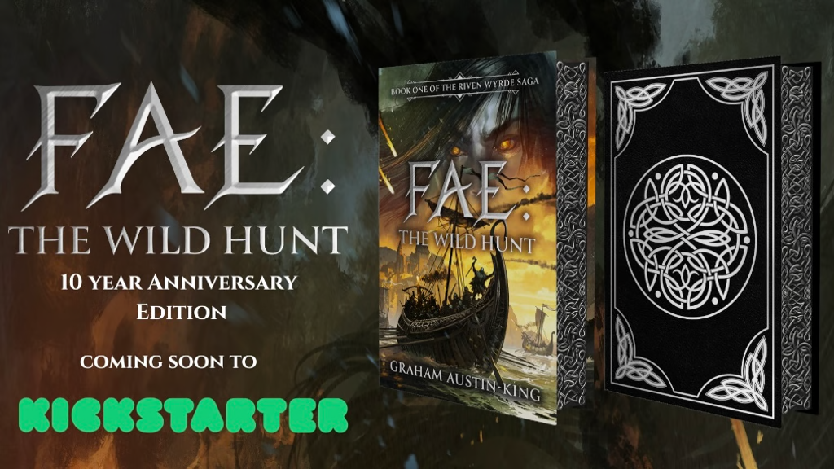
Make sure to check out Graham Austin-King’s 10th anniversary edition of Fae: The Wild Hunt on Kickstarter. This one looks amazing and just look at that cover! I have provided the Kickstarter link below along with the book blurb!
Fae-The Wild Hunt 10th Anniversary Edition Kickstarter Link
Book Blurb: The unforgettable story of a world on the brink of war. Where Bjornmen raiders are turning from plunder, to outright conquest. Where the truth of the fae has been forgotten.
History becomes legend.
Legend fades to myth.
But some myths are a warning.
Klöss wants nothing more than to pass the trials and join the ranks of the Bjornmen raiders, following in the footsteps of his forefathers. But times are changing in the Barren Isles. Coastal plunder is making way for outright conquest, and the threat of war is looming.
Found abandoned in the forest, Devin leads a simple life. But fate, it seems, has other plans. As his sleepy village transforms in the face of foreign invaders, whispered rumours tell of creatures in the moonlight, shadowy figures with eyes of amber flame. As the first battles rage, only one man seems to know the truth about the Fae, but can Devin or Klöss convince anyone before it is too late?
A reluctant coming of age epic set in a fantasy world. Packed with heroic sword fights, fierce battles and the political schemes of two worlds, The Riven Wyrde Saga is perfect for fans of Patrick Rothfuss, Peter V. Brett, and Brandon Sanderson. Find out why thousands of readers have fallen for Amazon #1 Best Selling author Graham Austin-King’s epic fantasy series.
Herman Steuernagel: The Greatest Pub in the Multiverse

I have interviewed my friend and fellow podcaster Herman Steuernagel twice so far on my podcast. We always have a great time chatting about his writing and our joint experiences podcasting. Herman runs the Greatest Podcast in the Multiverse and it is a good one! Make sure to check out his newest cozy fantasy The Greatest Pub in the Multiverse. Check out his newest book link in the space below.
Book Mail #1-The Bartender Between Worlds by Herman Steuernagel
Season 3, Episode 34-The Greatest Podcast in the Multiverse Crossover w/ Herman Steuernagel
Season 2, Episode 43-Herman Steuernagel Interview
The Greatest Pub in the Multiverse Amazon Link
Book Blurb: The Greatest Pub in the Multiverse is a heartwarming cozy fantasy tale of friendship, rest for the weary adventurer, slow burn romance, and the magic of second chances.
When James O'Sullivan returns to his hometown of Cuanmore to settle his estranged father's estate, he uncovers a life-altering secret: his family's pub holds a portal to a magical speakeasy, one that connects to worlds James once thought only existed in fantasy stories.
As James grapples with his new role as the reluctant caretaker of The Pint & Portal, he must confront the ghosts of his past and open his heart to the pub's colorful cast of regulars. Among them is Emma, a former witch hunter seeking redemption for her past misdeeds.
When an old magic threatens to shatter the fragile peace of The Pint & Portal, James and Emma must rally their newfound family to protect the pub and the magic it represents. In doing so, they discover that the true power of The Pint & Portal lies not in its enchanted brews or mystical patrons, but in the love, laughter, and understanding that can be found within its warmly lit walls.
The Greatest Pub in the Multiverse is a cozy, heartwarming fantasy celebrating the beauty of found family, the strength of compassion, and the extraordinary magic in life's quiet moments. Perfect for fans of Travis Baldree, TJ Klune, and anyone who believes in the magic of kindred spirits found in unexpected places.
Alin Silverwood: Sky Guy and the Altitude Adjustors Issue 1 Kickstarter Campaign
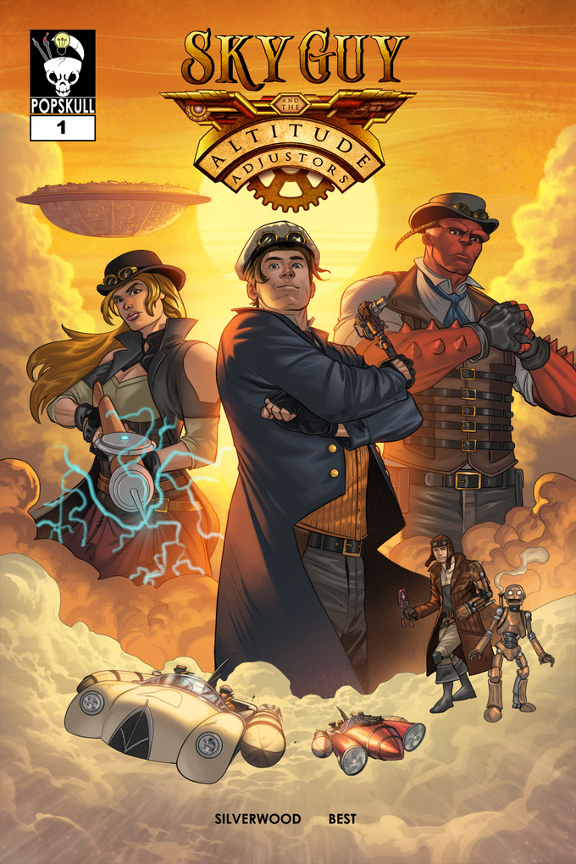
My friend Alin Silverwood’s newest Kickstarter: Sky Guy and the Altitude Adjustors is now live on Kickstarter! Alin really knows his comics as he has been in the business for a long time. We first discussed his last Kickstarter SPIs Among Us for my first episode almost four years ago. I am looking forward to backing this Kickstarter as well as the story sounds awesome and the art looks amazing. Make sure to check out my newest episode with Alin this Saturday, February 1st at 12 am EST.
Season 1, Episode 1-Alin Silverwood Interview
Sky Guy and the Altitude Adjustors Kickstarter Link
Kickstarter Description: Prepare to enter a fascinating world of Steampunk, mutants, and... perhaps a bit of magic. Our first issue will introduce you to an extraordinary cast of characters and astounding situations. Sometimes the strongest potential for hope arises from the worst of times.
The World:
Aerotowns are the population centers of civilized society, floating above the surface of a world teeming with mutated, and more primitive, lifeforms. The Aerotowns are, however, ancient -- and due to lost knowledge, only Altitude Adjustors know how to maintain them and keep them suspended in the atmosphere. But a single act of sabotage will begin a chain of events that change their entire world forever.
The Characters:
Aaron Skye is a daring ace pilot (reluctantly, as he suffers from a fear of heights... hence the "daring") who -- as "Sky Guy" -- has assembled the best team of Altitude Adjustors in Aerotown Vernen. His team consists of:
Marbury - a Groundling (mutant from the planet's surface) who is as brainy as he is brawny. Despite the disdain for "Ground Monsters" from Aerotown folk, Marbury is Skye's right-hand guy. It could get him into trouble.
Sarina - a bit on the wild side, Sarina has an overdeveloped expertise for weapon craft. It could get her into trouble.
Loris - the brother of Sarina, Loris never imagined a device he couldn't tinker into existence. It could get him into trouble.
Tom - the automaton brought to "life" by Loris, Tom has developed a baffling tendency to initiate functions he wasn't meant for. And a growing dedication to Loris that will absolutely get the poor little fellow into trouble.
The Story:
When someone sabotages a work assignment and endangers the team, and the Aerotown, they are suspended without pay, and one of their team is seriously injured. Unsure of when the saboteur will be found and revealed, Skye and company find themselves in need of income from other (and possibly even more dangerous) jobs. Sell contraptions to pirates? Maybe not. Surface black market runs? Not Sky Guy's favorite option. But the... attacks... continue as they begin the task of sorting it all out. Who's got it in for them, and why? And what explosive revelations will be unveiled along the road to discovery?
Nathan Webb: Troop Leader Windrush- Rocket Troopers Don't Retire: 1
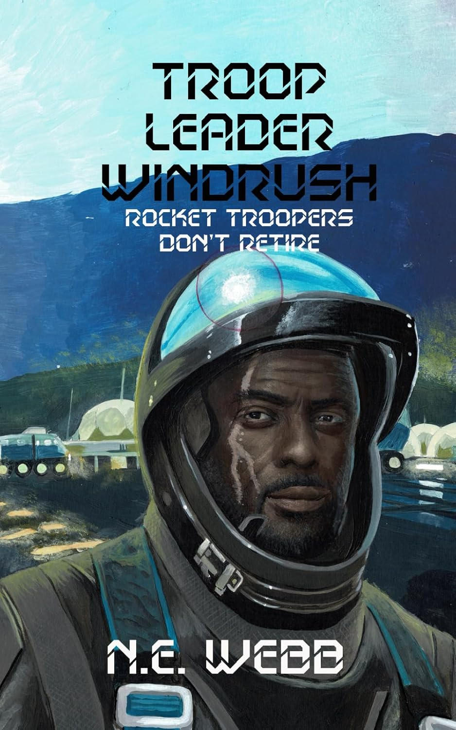
Make sure to check out N. E. Webb’s newest science fiction novel Troop Leader Windrush: Rocket Troopers Don’t Retire. This one sounds awesome so you should definitely check out the blurb and the Amazon link below.
Troop Leader Windrush: Rocket Troopers Don't Retire Amazon Link
Book Blurb: Once he was the cream of the Colonial military, commanding a team of infamous Rocket Troops with dozens of successful combat missions to his name. Troop Leader Windrush was hoping to retire from service gracefully with his reputation intact but he’s ran out of time, his Planet is scheduled for terra-scorching and he’s being pursued across the galaxy by the Earth Evacuee Space Force that’s been hunting him down for over six decades.
In his youth he was the poster boy for war, the deadliest Rocket Trooper that ever flew and he basked in the glory and accolades. Not counting his time in Cryo-sleep, Windrush is turning fifty-five and war is a young man’s game. Haunted by the hellish brutality of war and riddled with doubt of his current capabilities and degrading fitness. His health is failing him, but his heroic status makes him too important to the war effort to be allowed to watch from the sidelines.
He desperately needs to stay alive long enough to get his nomadic colony to safety on planet LHS 475 b (only 41 light years from Earth). But can he do it before his own colony uncover his deadly secret?
Amy Hutchins: New Youtube Channel

I had the pleasure last season of interviewing NYC-based actor, accent nerd, and narrator Amy Hutchins (Amelia Hugh). She has a new Youtube Channel so please make sure to subscribe and check out her work! You can find my interview with her in the space below!
Season 3, Episode 20-Amy Hutchins Interview
Amy Hutchins Youtube Channel Subscription Link
B.S.H Garcia: In the Shadow of Duty
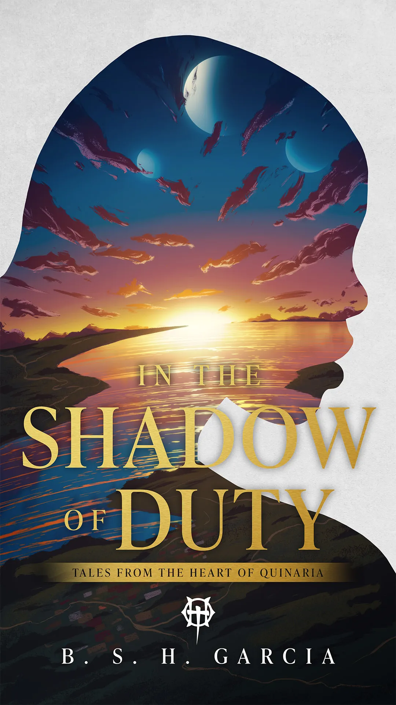
I am so excited to see that B. S. H. Garcia has a new release! Here is the cover and the blurb so please make sure to check them out! I have her book Of Thieves and Shadows on my 2025 Reading List and I am very excited to start her series and enter her world and to start the adventure with her characters.
In the Shadow of Duty Link
Book Blurb: A good soldier follows orders.
An assassin, haunted by a dark past, is ordered to eliminate a rebel sympathizer. When she discovers a child caught in the conflict, her mission unravels. With enemies closing in and time running out, she must decide between following the empire’s orders or risking everything to protect the child.
Failure could cost her more than just her mission—it could destroy everything she’s ever known.
This is a stand-alone short story set in the land of Quinaria.
In the Shadow of Duty is an interactive short story that takes place over two thousand years prior to the events in Of Thieves and Shadows—volume one in the epic fantasy series, The Heart of Quinaria—and picks up shortly after the events in From the Ashes (though reading that first is not required). It is available for FREE through the Unearthed Stories application in partnership with Prowess Games. This story is similar to that of a choose-your-own-adventure structure and has multiple branches and endings based on what decisions are made by you, the reader.
Sabrina Roznowski: Wrath of the Wreya
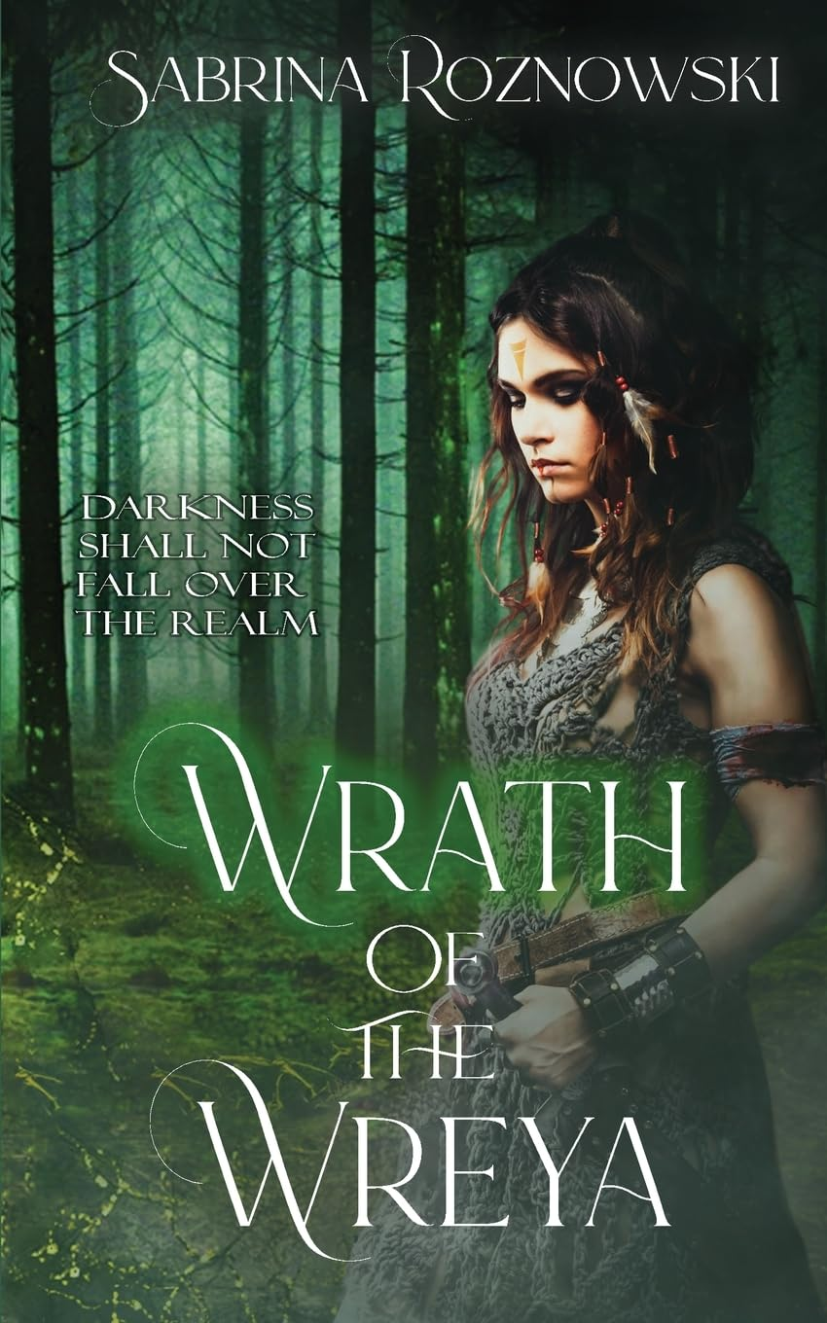
My friend Sabrina Roznowski has a new book out! I am really excited for her and to see where her newest release takes her. Make sure to check out the Amazon link below and check out the blurb for Wrath of the Wreya in the space below.
Wrath of the Wreya Amazon Link
Book Blurb: In a war-torn land, two unlikely allies must face their demons to bring about justice and change…
Reyna lives with fear and tyranny. A fierce young warrior, she seeks only to survive. But when her beloved is killed at the hand of the king’s guard, her purpose becomes revenge. She will stop at nothing to avenge the man she loves.
Derrick, the youngest son of the king Reyna seeks to destroy, is haunted by his weakness. A coward by nature, he flees when he discovers his brother’s plot to kill him. Fate leads him to the unexpected sanctuary of a warrior tribe where his kind heart is met with scorn.
Reyna takes the cowardly prince under her wing, determined to transform the trembling boy into a man who can help her destroy his father’s throne—no matter the cost. But as Reyna trains Derrick in the ancient ways of combat, another battle rages within her heart. Can she sacrifice Derrick to satiate her need for revenge?
As their alliance strengthens, old prophecies and ancient secrets bind their futures together. Reyna and Derrick journey to confront the king and bring justice to the land. To claim justice and seize their destiny, Reyna and Derrick must pierce the heart of darkness threatening to consume their land while facing their fears and challenging their convictions.
The power of unity, love, and growth are put to the ultimate test. Join them on this thrilling adventure as they strive to restore hope to their war-torn land—and their battered hearts.

